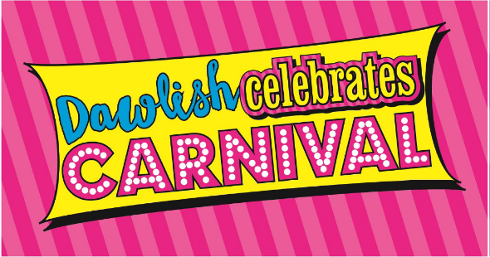
VIRTUAL DOG SHOW 2020
Contact Name *
Contact Number *
Contact E-Mail
Which category are you entering? *
Choice of Most Gorgeous, Scruffiest and Most Like Owner
Dog Name ( plus owner for most like owner) *
Please attach a photo of your dog. *
*Required fields
If you have trouble filing in the form online or can’t fill in the Google survey form just send an email with the same details as above and a photo to stalls@dawlishcelebratescarnival.co.uk

